Keo's Tall Tale
Style Guide

Swamp Area
Aesthetics
As the game starts off in the forest, they should start off with round/soft edges. The forest is a place Keo and his friends are familiar with, so it should seem welcoming and inviting. As the player gets close to the Swamp, the welcoming round/soft edges that the forest had will become a bit sharper, to show unfamiliarity to the player and the danger that could be in the swamp.

- Trees should have little to no leaves on them compared to the lush forest.
- There will be moss on the trees, that are in or very near the water.
- Trees shouldn't be healthy, they should be broken, mangled, distressed, dying.
- There shouldn't be bushes, but a transition from the forest to the swamp can have them.
- Instead of tons of bushes, lush vegetation, we move to grass, dead trees, lots of water.
- The water will not be nice and clean as though it came from a spring, but dirty, like it has been sitting there for a while it will transition from a clean water, too dirty, to greenish to show something is contaminating the water as part of one of the puzzles the player will have to get around.
- Water and the ground will be set up in tiers to give it more of an atmosphere.
- The peak of dead trees, muck in the water should become more common as the player gets further into the swamp, and at its peak right in the middle of the swamp area.
- The swamp will have different types of enemies. Alligators, piranha type fish and so on.
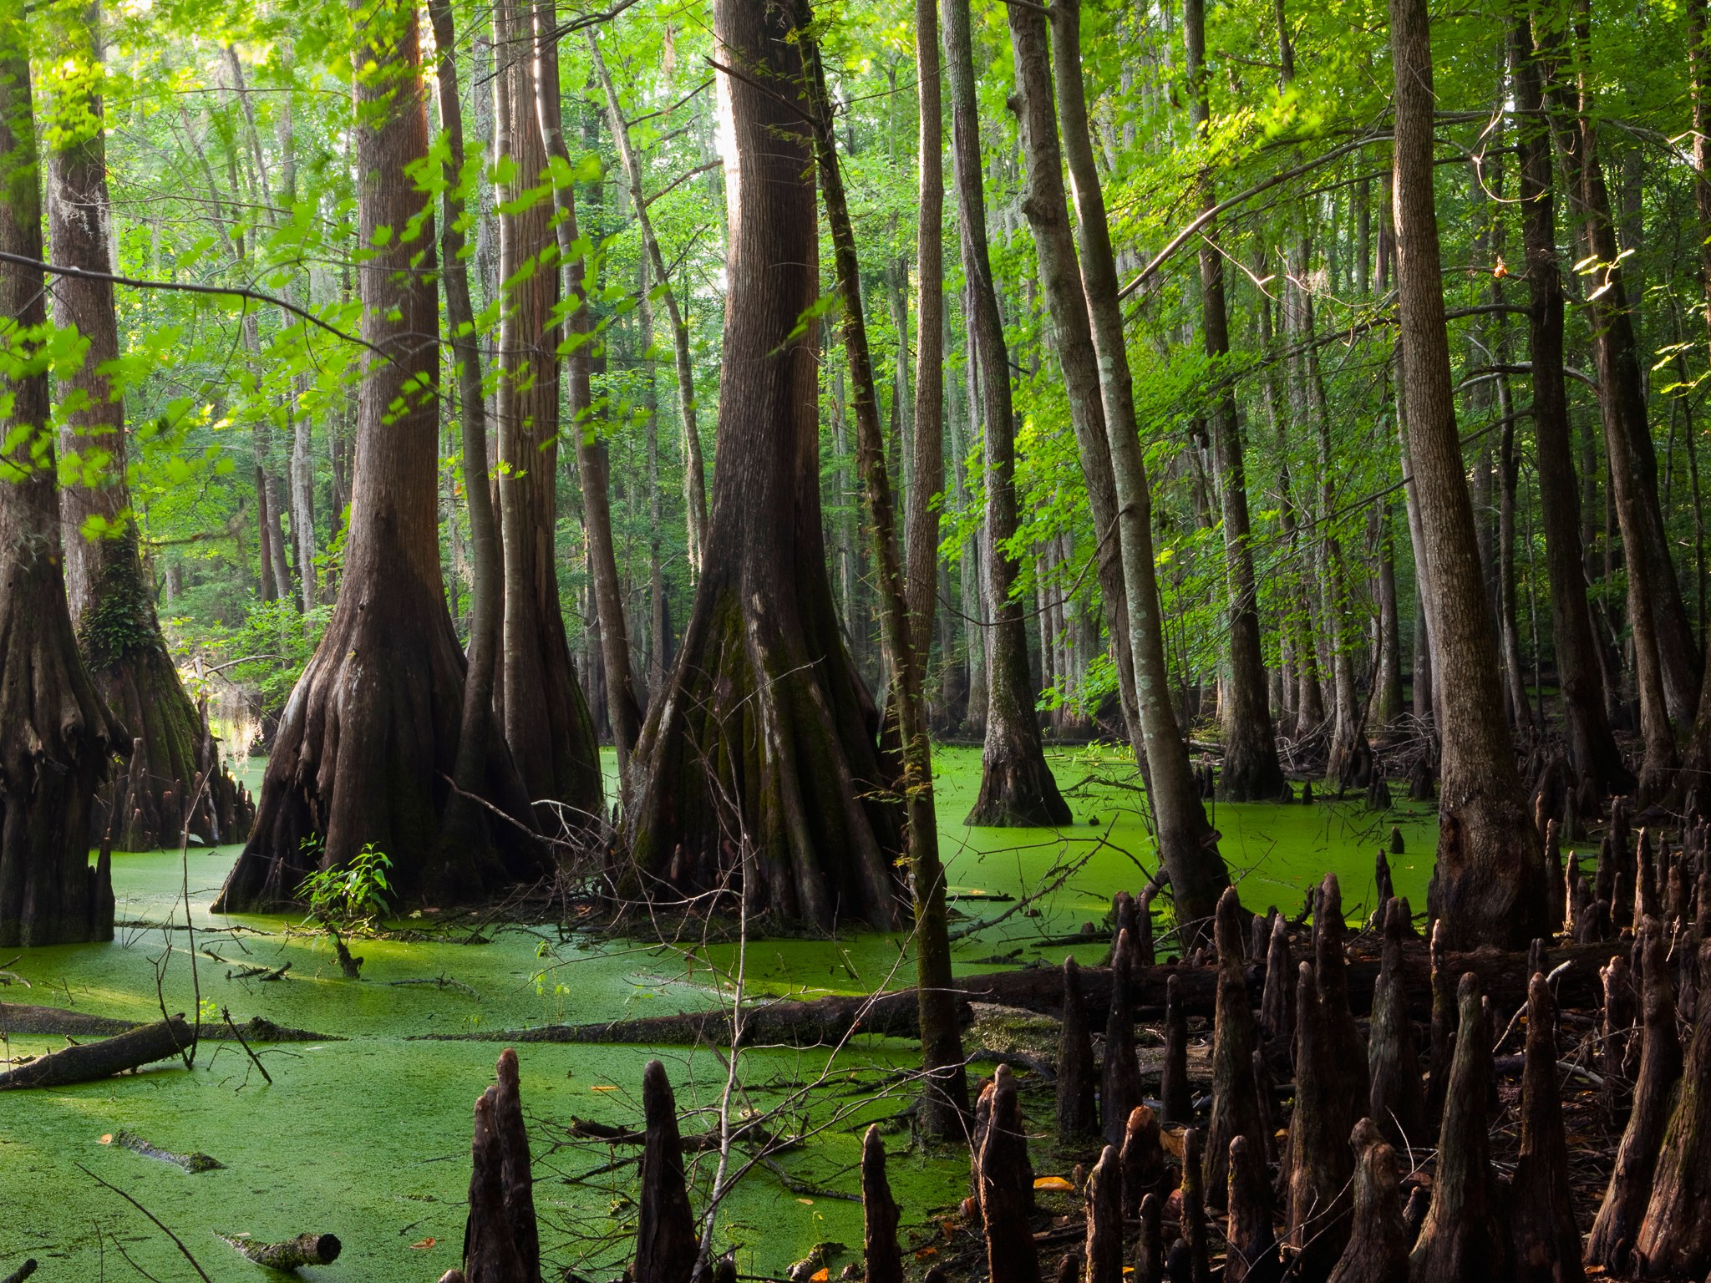
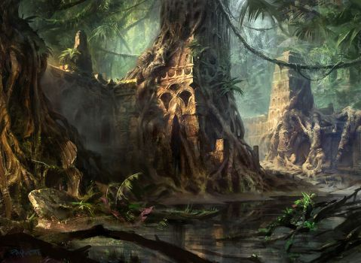
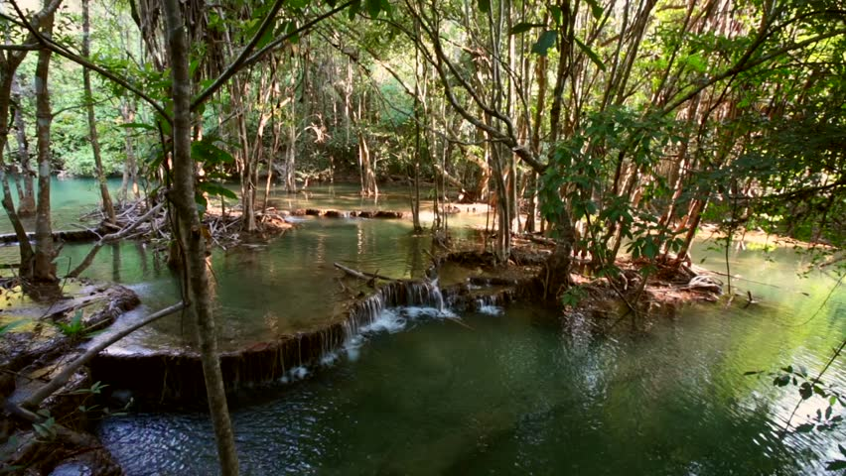
- Any buildings in the swamp will be overgrown. Nature is taking back the swamp.

Color palette:
The swamp will be a bit darker than the forest. More muted greens and browns due to lighting. Greens will mostly be part of everything from trees, buildings, rocks to show overgrowth.



Audio:
Low noises, crickets, maybe some birds that are local to the area, creaking wood as things settle in the ground a bit.

Visual Effects:
Small water fall effects between the tiers. Fireflies throughout the swamp. Fog effect around the water areas.

Temple Area
Aesthetics
The Temple area will become very rough/hard edges. The Temple area is in ruins. It has been abandoned for centuries. This area has only been visited by those seeking treasure. Make it a new area not only for the character, but the player as well. There will want to be wonder for the player here.
- Trees should begin to become more lush as we transition into the temple. Trees will be ground on and around the walls.
- The grass has overtaken the entrance to the Temple. You can still see the remnants of a walkway. Grass has been growing in between the pavement for the Temple.
- Vegetation will be mainly trees and grass. Some bushes will be growing around the walls, near trees.
- Instead of tons of bushes, lush vegetation, we move to grass, dead trees, lots of water.
- Walls and columns will be collapsed in areas, or are in the transition of collapsing.
- Water and the ground will be set up in tiers to give it more of an atmosphere.
- Ground will have several pathways around the entrance to make it looked like it was traveled around years ago.
- In the temple there will be an old waterway, moss will grow around the rocks that are near the waterway.
- Give a feel of peace, religion, meditation throughout the temple grounds.
- The enemies in this area will be more traps that actual enemies. While there will be a boss, most things the player will run into here will be environmental. Such as falling floors, jump based puzzles, moving blocks to open doors.

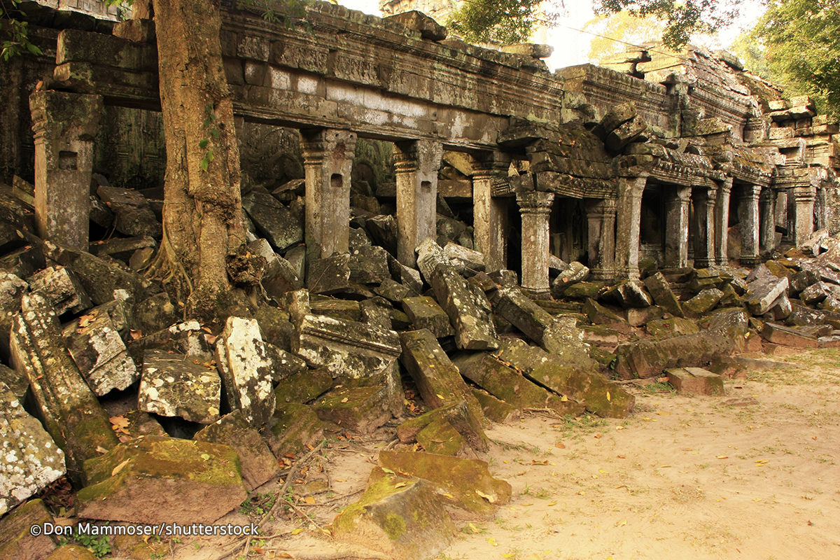
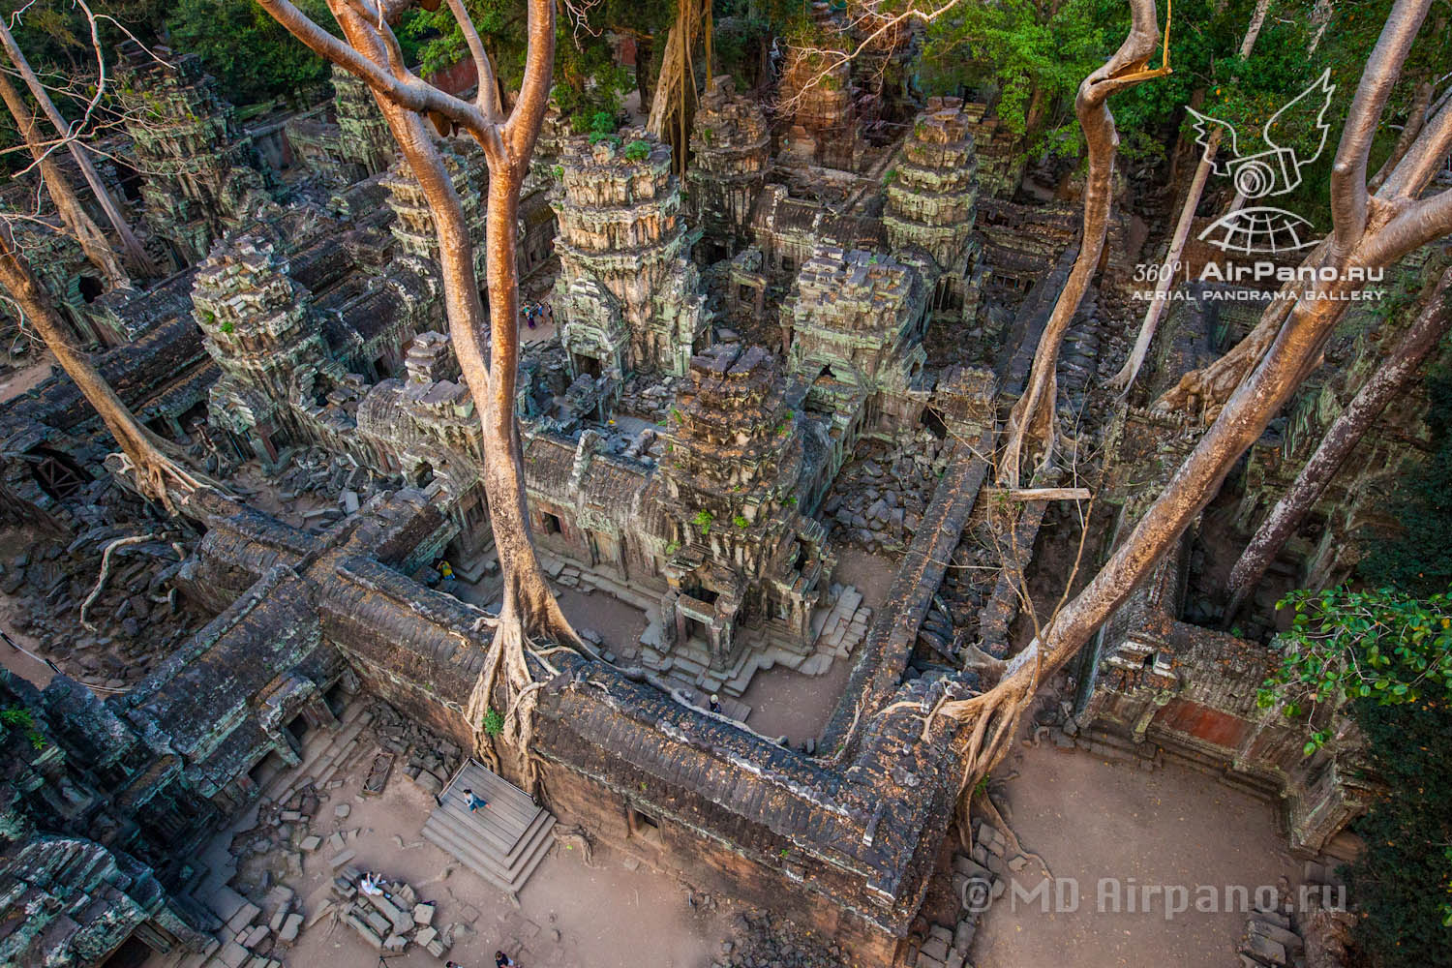

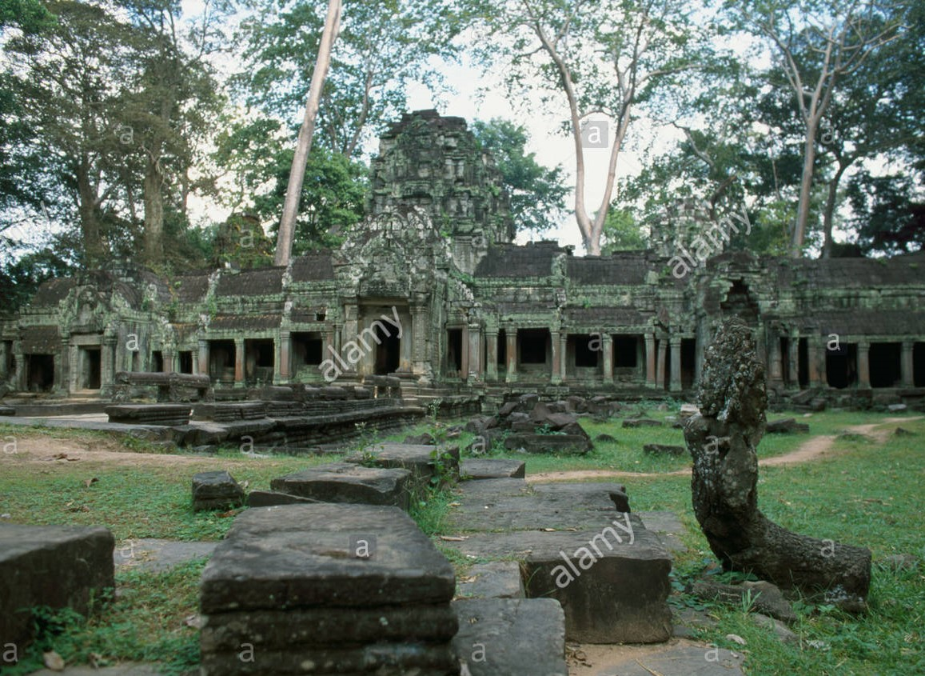

Color Palette:
- Taking into consideration what the stone was made of, what the paints would have been made of, possible copper, or other metals causing a green hue to the stones. Possibly blacking of the stones as well to really show age. Also, water wear on the stones to show weathering. Overgrowth colors will be browns and greens due to dirt, grass and the trees.



Audio:
will be somber, quiet, peaceful. Keep the vibe of being a place of religion, meditation. Very quiet Gregorian chant, or a very quiet Buddhist chant to keep the ambiance. Keep with slight crickets until the player gets into the temple.

Visual Effects:
beams of light every so often, giving an exalted feel to areas, hinting at things that you want the player to see in the Temple. If things move from their place, have dust that has settled move around.

Cave Area
Aesthetics
Caves will be prevalent in each area of the game, just to add more feeling of exploration for the player. The caves will be in the Forest, swamp. The temple wont have a cave but will have floors for the player to explore.
- Caves lighting will be darker since they are in a cave.
- Lighting for the cave will either be by a torch or possibly to make it more visually appealing have lighting provided by Bio-Luminescence.
- Cave will have stalactites and stalagmites.
- Cave will have wells, small water deposits the player will have to get through.
- Cave will have bats and other animals that will be native to the cave system
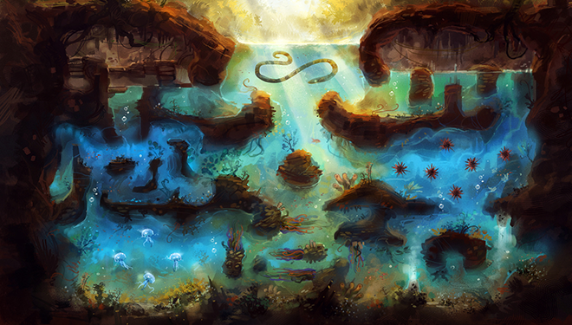
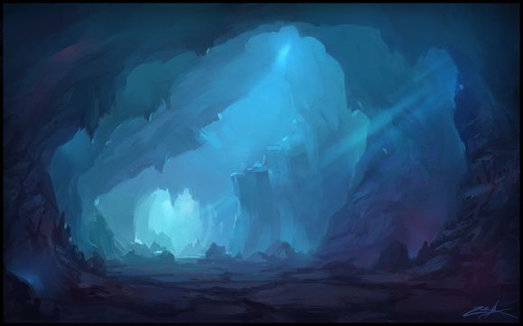
- The cave will have a damp feeling to it. Dripping water from the ceiling.
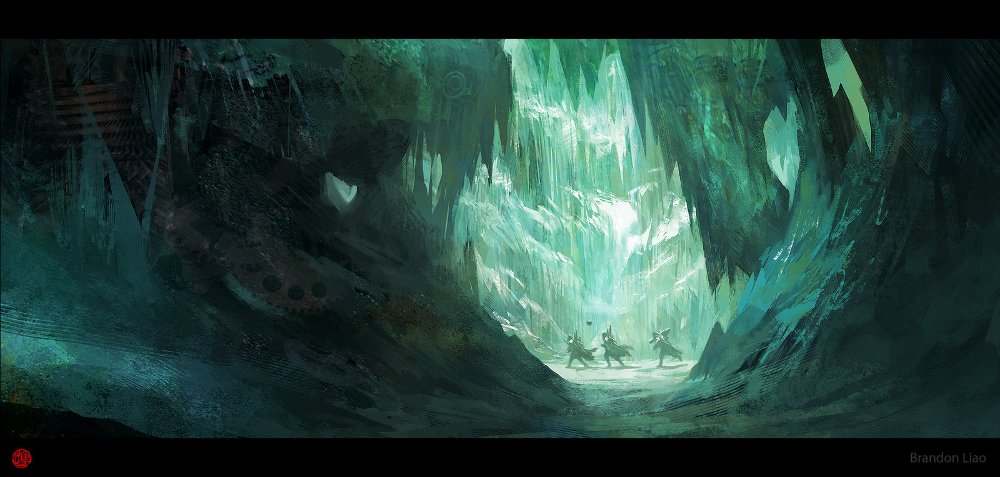



Color Palette:
Because the cave will be darker, the focus on colors will be blacks, blues, purples. The entrance will give more color shared by whatever parent environment it has. But the main colors will be shades of blacks, blues and purples. The Bio-Luminescence will help provide a break up of other colors, shared by a torch if the player is able to get one before entering the cave.

Audio:
There will be a lot of dripping, echoes, skittering, happening. Any music here will give a suspenseful feel as the player doesn't know what could be around the corner. The player shouldn't feel comfortable, but the music shouldn't scare the player.

Visual effects:
Dripping water from the ceiling, bio-luminescence should glow providing enough light for the cave, especially as the player gets further away from the entrance. Have eyes staring from the darkness will be good to give an uneasy feeling, the player should feel like they are in danger.

Overall feel for foreground, mid-ground and background.
Foreground:
Will contain silhouettes of the environment. Such as grass, bushes, trees, Enough so that it will look visually appealing, but none of this should block the players view from what they are doing. This will be above and below the players screen and if in front of the player, in places where it will not hinder their progress.

Mid-ground:
This is where most of the 3d assets and intractable objects will be for the player. This is where the character will be 100% of the time. The area will be a bit bigger than the play area though to give some atmosphere to what the player has access too do, while we restrict them in terms of game play.

Background:
This area will focus on a parallax affect. Having a mix of 2d and 3d will be important as to not make the game look flat. Having the 3d environment in front of a 2d background will give needed depth to the level. The 3d effect will be set up in layers. 2 layers of 3d objects to add depth while the final layer will be the 2d background.

